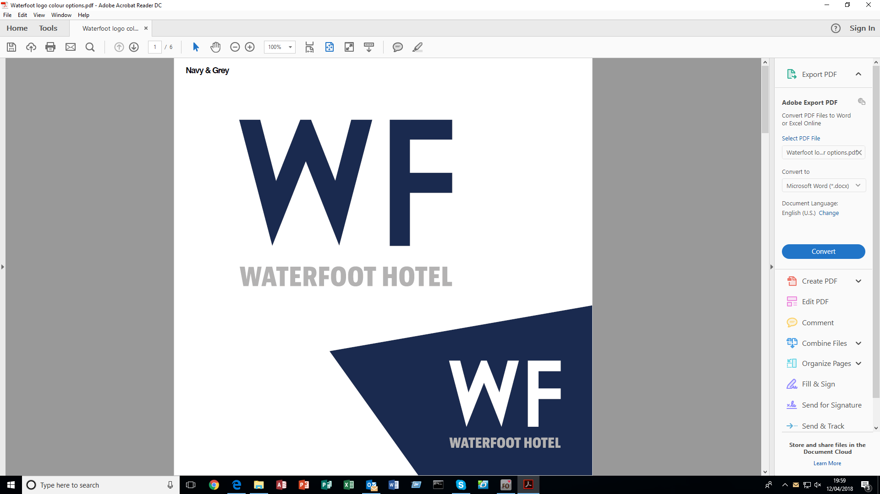

**Lunch Menu**

Available 12pm-4pm

Chef’s homemade Soup of the Day, Crusty Roll (1/2/7) **£4.95**

Sandwiches (2/4/6/7) **£4.95**

Toasties (2/4/6/7) **£5.25**

Paninis (2/4/6/7) **£5.50**

Add soup combo for **£3.00**

Please choose 2 fillings from the following: (additional fillings **£1.00**)

Ham, Cheese, Chicken, Bacon, Tomato, Red Onion, Tuna & Onion, Egg & Spring onion (4), Coronation Chicken (4/9), Coleslaw (4), Mixed Salad

Waterfoot Chicken, Bacon & Hen Egg Caesar Salad (2/4/5/7/14) **£9.50**

Goats Cheese Salad, Beetroot, Pickled Apple, Garden Leaves, Salad Dressing (9) **£9.50**

Northbound Ale Battered Greencastle Haddock, Tartar Sauce, Mushy Peas (2/4/5/7) **£10.95**

Homemade Madras spiced Chicken Curry, Rice, Naan Bread (1/2/4) **£9.95**

Open Steak Ciabatta, Peppers, Onions, Siracha Sauce, Garlic Mayo (1/2/4/6/7/14) **£10.95**

Homemade Panko Breaded Chicken Goujons, dips (2/4/7/9) **£9.95**

Arizona Chicken, Chorizo Cream, Tobacco Onions (1/2/7) **£9.95**

Homemade Lasagne, Garlic Bread, House Coleslaw (1/2/4/6/7/9/14) **£9.95**

8oz Steak Burger, Bacon, Cheese, Relish (2/4/6/7/14) **£9.95**

Penne Pasta, Chilli Chicken, Peppercorn Cream, Tobacco Onions (1/2/4/6/7/14) **£9.95**

Roast of the Day served with Mash Potatoes, Roast Potato and Vegetables (1/2/4/7/14) **£9.95**

*All above served with a side order of your choice*

Side orders **£3.50**

Chips, French Fries, Garlic Potatoes, Chilli & Crème Fraiche Fries (7), Mash (7), Champ (7),

Vegetables of the Day (7), Tossed Salad (9), Caesar Salad (2/4/5/7/14), French Fried Onion Rings (2/4/7), Tobacco Onions (2) (fried potatoes can be gluten free)

Sauces **£1.50**

Roast Gravy (1/7/14), Peppercorn (1/7/14), White Wine and Mushroom (1/7), Arizona (1/7)

Dips **£1.00**

Garlic (4/7), Sweet Chilli (1/9/14), BBQ (1/9/14)

*Food Allergens – 1- celery 2- Gluten 3 – Crustaceans 4 – Eggs 5 – Fish 6 – Lupin*

*7 – Milk 8 – Molluscs 9 – Mustard 10 – Nuts 11 – Peanuts 12 – Sesame Seeds*

*13 – Soya 14 – Sulphur Dioxide*