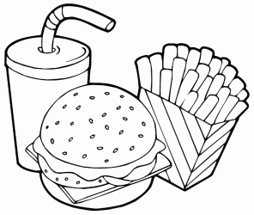

**KIDS MENU**

**TO START**

Garlic bread **£1.95**

Soup & Mash **£1.95**

**MAINS**

Chicken goujons & side **£5.95**

4oz burger & Side **£5.95**

Creamy chicken penne pasta & side **£5.95**

Sausage & side **£5.95**

Fish Fingers & side **£5.95**

**Sides:** Fries / mash/ garlics / vegetables of the day

**DESSERTS**

Ice cream selection **£1.95**

Chocolate fudge cake **£2.50**